Analogue Clock Layout Customization
Editing the digital clock is simple enough, simply setting the colours in the Advanced Options. Though, setting the layout of a fully-fledged Analogue clock is a quite different. There are a lot more things to consider. This is where the Analogue Clock Layout Customization window comes into play. This window allows you to customize the analogue clock.
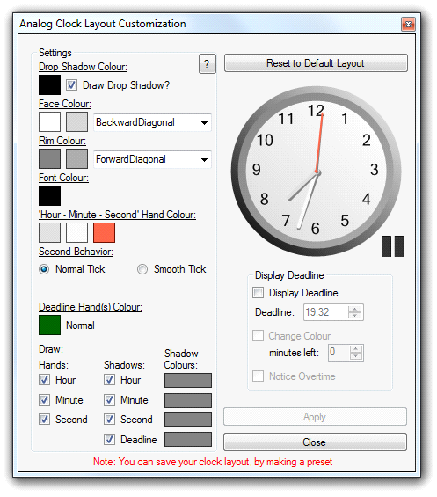
This window can seem very intimidating and with good reason. But it is rather straight forward. We’ll break it into sections so that it may be easier to consume.
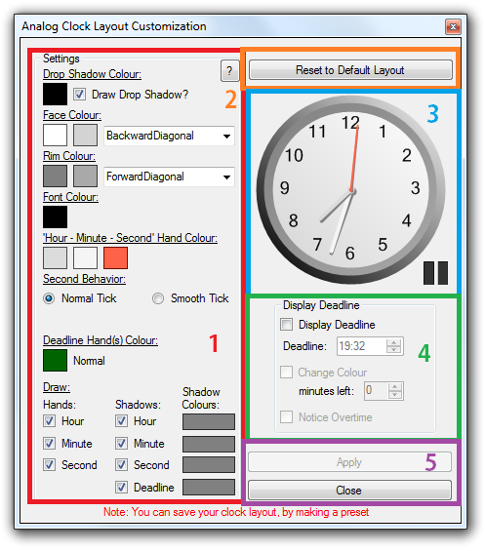
1: Settings
This section allows you to customize the clock. There are a lot of things to customize and it would take a long time to go through all of them, so the recommendation is to just play around with it and see how everything works. Descriptions are above each part.
You will be able to see everything live on the clock on the right side (see 3)
Things to note though, is the deadline properties colours are not displayed here as they are universal between the digital clock and the analogue. You can read more about this in Advanced Options. Also, setting the “Display seconds” in the Advanced Options does not alter the analogue clock, only the digital ones. You can also read more about his in the Advanced Options.

2: Reset to Default Layout - Button
This section is really just one button. This button allows you to reset the layout back to the default one, sort of like getting a blank slate to work from. Convenient when you want to start over.

3: Analogue Clock display
This section displays a live example of what your clock will look like. This clock will update live as you change the layout on the left side (see 1). You have a button on the right bottom side of the clock; this allows you to pause and resume the clock.

4: Display Deadline
This, like in the main window, will allow you to display the deadline on the clock. Only this one is merely there for demonstration purposes: To see how the deadline hands will look in your layout. Consider the deadline properties, which are located in the Colours Tab in Advanced Options. Please look at Advanced Options for more information on this.

5: Apply & Close Button
This section contains the two buttons to complete or discard your progress. Pressing the Close Button merely discards your work, while the Apply button allows you to apply the layout to your Analogue clock type. Keep in mind that pressing the Apply button does not automatically apply it. You also have to press the apply button in the Advanced Options. A message will be shown next to the button, telling you that your analogue layout is ready to be applied.

Also, as the text says in the bottom of the Analogue Clock Layout Customization window, you can apply your layout to a Pre-set by creating one afterwards you’ve applied in the Advanced Options window.

